**Project Design Phase-I**

SOLUTION ARCHITECTURE

|  |  |
| --- | --- |
| Date | 19 September 2022 |
| Team ID | PNT2022TMID09860 |
| Project Name | Early detection of forest fire |
| Maximum Marks | 4 Marks |

**Solution Architecture:**

Solution architecture is a complex process – with many sub-processes – that bridges the gap between business problems and technology solutions. Its goals are to:

* Find the best tech solution to solve existing business problems.
* Describe the structure, characteristics, behaviour, and other aspects of the software to project stakeholders.
* Define features, development phases, and solution requirements.
* Provide specifications according to which the solution is defined, managed, and delivered.

**Example - Solution Architecture Diagram**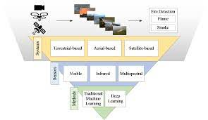

**Architecture of detection of forest fire:**

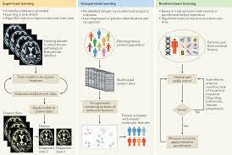

**Reference:** Chen, Y.; Sano, H.; Wakaiki, M.; Yaguchi, T. Secret Communication Systems Using Chaotic Wave Equations with Neural Network Boundary Conditions. *Entropy* **2021**, *23*, 904. [[**Google Scholar**](https://scholar.google.com/scholar_lookup?title=Secret+Communication+Systems+Using+Chaotic+Wave+Equations+with+Neural+Network+Boundary+Conditions&author=Chen,+Y.&author=Sano,+H.&author=Wakaiki,+M.&author=Yaguchi,+T.&publication_year=2021&journal=Entropy&volume=23&pages=904&doi=10.3390/e23070904)] [[**CrossRef**](https://doi.org/10.3390/e23070904)]